 | NOTA TECNICA  TECHNICAL REPORT |  |  | Núm.  No. | TAE-T-NT-150156
 | Departamento Department |  | Stress Methods  (TAETS13) | Avión  Aircraft | Technologies
Título/Title
PROGRAM ARES, VERSION 4. USER’S MANUAL.
Palabras clave/Key words |  |  |  |  | Clasificación acceso  Access class
SOFTWARE, JOINTS, REPAIR, RIVETS, ADHESIVE |  |  |  |  | P1
Registro de Revisiones
Revision Record
 |  |  |  |  | Pag. 2
Resumen/Summary
This document is the user’s manual of program ARES, version 4.
The ARES program calculates the distribution of internal loads in different elements of a riveted and/or bonded joint between metallic and/or composite materials. The program takes into account the non-elastic behaviour of adhesives subjected to shear forces. External loads may be axial or shear, and thermal stresses are included in the calculations.
PROPIEDAD DE AIRBUS DEFENCE AND SPACE S.A.U.. Este documento no puede ser utilizado ni reproducido total o parcialmente sin la previa autorización escrita de la Dirección de Ingeniería de Aviones Militares AIRBUS DEFENCE AND SPACE S.A.U..
AIRBUS DEFENCE AND SPACE S.A.U. PROPERTY. This document shall neither be used nor completely or partially reproduced without previous written authorization of AIRBUS DEFENCE AND SPACE S.A.U. Military Aircraft Engineering Directorate.
Distribución/Distribution |  | Realización/Execution |  |  | Edición/Issue  Fecha edición/Issue date
A
November 2015
Structural Analysis (TAETS1) |  | Realizado  Prepared |  |  | Firma  Signature
Structural Mechanics  (TAECA33) |  |  | Gustavo Baños Lapuente
 |  | Comprobado  Checked | Darío Fernández Villalba
 |  | Aprobado  Approved | Darío Fernández Villalba

REGISTRO DE REVISIONES/REVISIONS RECORD

Revisión | Motivo de Modificación / Change reason | Realiz./Prep. | Compr./Check. | Aprobado/App.
Fecha/Date | Capítulos, Secciones, Hojas afectadas / Chapters, Sections, Sheets affected | --- | --- | ---
A | Primera edición / First issue | Gustavo  Baños | Darío  Fernández | Darío  Fernández
Novem-ber 2015 | Todas las páginas / All pages | --- | --- | ---

INDEX
1 INTRODUCTION 4
1.1 TECHNICAL SHEET OF THE PROGRAM 4
1.2 SOFTWARE PURPOSE AND DESCRIPTION 5
1.3 ABBREVIATIONS AND SYMBOLS 6
1.4 REFERENCES 7
1.5 DIFFERENCES AMONG VERSIONS 7
2 PROGRAM EXECUTION 9
2.1 WINDOWS/PC VERSIONS 9
2.2 UNIX/MULTIVAC VERSION 9
3 INPUT DATA 11
3.1 WINDOWS PC/GUI 11
3.2 INPUT FILE 15
4 OUTPUT RESULTS 24
4.1 WINDOWS PC/GUI 24
4.2 OUTPUT FILE 24
4.3 WARNING AND ERROR MESSAGES 26
5 LIMITATIONS 29
6 EXAMPLES 30

INTRODUCTION

TECHNICAL SHEET OF THE PROGRAM
Technical Report: TAE-T-NT-150156

PROGRAM DATE
ARES 10/2015

OBJECTIVE
The ARES program calculates the distribution of internal loads in the different elements of a riveted and/or bonded joint between metallic and/or composite materials. The program takes into account the non-elastic behaviour of adhesives subjected to shear forces. External loads may be axial or shear, and thermal stresses are included in the calculations.

LANGUAGE DEVELOPMENT TOOLS OS/PLATFORM
Fortran 77 MSVS & Oracle Solaris Studio Unix (Solaris) and Windows (x86)
Visual Basic Net MS Visual Studio 2013 Windows (x86)

NUMBER OF LINES (APPROX.) EXECUTION MODE
5400 (Fortran, analysis core) Console (input data in text file)
+ 3300 (Visual Basic .Net) Interactive GUI
Total 8700

Notes:
- Blank lines and commented lines excluded
- Count for Visual Basic code excludes lines created by Visual Studio in designer.vb files

AUTHOR VERSION
Fernando de Nicolás López 1.X – 2.X
Lucas Claramonte Clausell 3.X
Darío Fernández Villalba 4.0

ADDITIONAL DOCUMENTS
See list of applicable references in chapter §0.

SOFTWARE PURPOSE AND DESCRIPTION
This manual describes the use of version 4 of the ARES program, including an example to further clarify its use.
This program calculates the distribution of internal loads in the different elements of a fastened and/or bonded joint. The loads on each fastener, the strain on the adhesive segments and microstrains in the joint elements are calculated.
The elements to be joined may be metallic or composite materials. The different failure modes of fastened joints are taken into account.
The program takes into account the non-linearity of adhesives subject to shear forces, whether or not fasteners are also used in the joint.
External axial or shear loads may be defined, acting on the ends of the elements that are joined. These are combined with any thermal loads that may exist.
Linear (unidirectional) joints may be analysed.
The program only analyses single shear connections. Double shear connections must be transformed to single shear connections before calculation.
After calculating the internal loads, the program checks the strength of the elements involved: fasteners, adhesive and the elements being joined.
The program performs the following operations:
- Read a data file prepared by the user, containing the geometric and material properties of the elements to be joined and of the fasteners and adhesive.
- Calculate the distribution of strains and deformations of the elements involved in the joint.
- Check the strength of the elements involved in the joint.
- Generate a results file, which includes:
- The distribution of strains and deformations in the elements being joined.
- The loads transferred by the fasteners.
- The distribution of strains and deformations in the adhesive.
- Reserve factors of the elements being joined, the fasteners and the adhesive.

This version is provided with a graphical interface (GUI).

ABBREVIATIONS AND SYMBOLS
Symbol Units Definition
GUI Graphical User Interface
I/O Input and Output
MSVS Microsoft Visual Studio 2013 (plus Intel Visual Fortran Compiler version 14 and IMSL Fortran Numerical Library version 6.0.0)
X mm Location of point in X axis
t mm Thickness
E MPa Material Young’s modulus in tension
G MPa Material shear modulus
F_{sy} MPa Material yield stress in shear
F_{su} MPa Material ultimate stress in shear
F_{tu} MPa Material ultimate tension stress
F_{bru} MPa Material ultimate bearing stress (metal alloys)
W mm Adherent section width
Nuxy - Material Poisson’s ratio
A με Allowable by-pass strain around a riveted/bolted attachment
B MPa Allowable bearing stress for the tension-through-hole failure at a riveted/bolted attachment
C MPa Allowable bearing stress for the bearing failure at a riveted/bolted attachment
Px, Py N Axial loads applied at left ends of elements/adherents X and Y
Rx, Ry N Axial loads applied at right ends of elements/adherents X and Y
Qx, Qy N Shear loads applied at left ends of elements/adherents X and Y
Sx, Sy N Shear loads applied at right ends of elements/adherents X and Y

REFERENCES
Document Reference Issue Title
- NT-T-ADP-99026 A Manual Teórico del Programa ARES, Versión 2.2
- NT-T-ADP-03001 A Manual del Programador del Programa ARES, Versión 2.x
- NT-T-ADP-01032 A Program ARES, Version 2.x. User’s Manual.
- NT-T-ADS-97002 A ESPECIFICACION DEL PROGRAMA DE CALCULO DE CARGAS INTERNAS EN REPARACIONES DE ELEMENTOS LINEALES Y BIDIMENSIONALES. PROGRAMA ARES_V1.0.
- NT-00-ECE-037 A ADMISIBLES DE FALLO DE UNIONES REMACHADAS EN MATERIALES COMPUESTOS
- TAE-A4-MM-150040 A Análisis de parches remachados: diferencias entre ARES y FEM
- [CASA] - MANUAL DE DISEÑO CASA, VOL. 11

DIFFERENCES AMONG VERSIONS

Changes from versions 1.0 to 1.1
Version 1.1 corrected the following errors detected in version 1.0:
Errors in data input:
- Data for the elements being joined was wrongly read when the input line was longer than 80 characters.
Errors in the results file:
- The program title page was omitted in the case of bidimensional problems.
- Output format errors.
- Some headers were in Spanish, while the rest of the file was in English.
Errors in the calculations:
- The reserve factor calculation was erroneous in regions joined by adhesive where the thickness varied.
- The calculations for non-elastic adhesive joints in which the strains are not symmetrically distributed through the adhesive were faulty.

Changes from versions 1.1 to 2.0
Version 2.0 corrected errors detected in version 1.1:
Errors in the calculations:
- An error occurred when analysing bidimensional adhesive joints, because the program tried to analyse the corner fastener, even though this does not exist.
- An "invalid operation" error that occurred during one analysis has been corrected.
- Apart from this, version 2.0 includes the following improvements:
New characteristics:
- The program can now calculate the allowable limits for fastened joints in composite materials, as a function of the geometry of the problem.
- The source code has been revised to allow it to be compiled on the SUN computer and in PCs, as well as in the VAX.

Changes from versions 2.0 to 3.0
This version has been provided with a Graphic User Interface in Visual Basic 6, as well as an interactive input in English or in Spanish at user’s choice.
Several bugs detected in the former version have been also removed.

Changes from version 3.0 to 4.0
GUI version for Windows is rewritten and built in VB.Net according to the applicable standards of the Airbus DS stress software, after several bugs were reported affecting the GUI interface.
Bi-dimensional analysis is disabled (see Ref. 6). FEM tools are recommended for analyses of those cases (as BOLTEDREPAIRFEM).
Internal calculation of allowable values of composite bolted joints is disabled. This task shall be done explicitly, prior to ARES run, with URCO.

PROGRAM EXECUTION

WINDOWS/PC VERSIONS
The Visual Basic executable program Ares.exe (as well as an electronic copy of this manual and the program examples) is located in the folder:
\\Cae\InfoCalculo\Soft\Ares
To execute the program, the user has to click twice on the Visual Basic executable program.

        - Welcome screen of the Windows GUI version of ARES

There is another executable file with the same name, which is the Fortran program in console mode, in the subdirectory .\Consola within that folder (and another copy of the console-mode executable in \\Cae\InfoCalculo\Soft\Consola, this last path than can be added to the Windows system PATH to facilitate its use).

UNIX/MULTIVAC VERSION
To run interactively this version of the program (console application), you must have already done the assignment of the symbols list in Airbus DS Structural Analysis Office using the command:
. asignaciones_calculo
This instruction can be executed in the commands terminal prior to execute the program, but it is strongly recommended to include this statement in the files ".profile", and ".kshrc" (if working in Korn Shell) or ".bashrc" (if you work in Bash Shell). To do this, the following lines should be included in the file ".profile":
. asignaciones_calculo
ENV=$HOME/.kshrc
export ENV
BASH_ENV=$HOME/.bashrc
export BASH_ENV
In files ".kshrc" and ".bashrc" the following line shall be added:
. asignaciones_calculo

The instruction to run the program in interactive mode in the MULTIVAC server is:
$ares
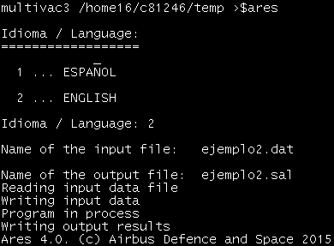
        - Interactive execution of the Unix console version of ARES
This console application can be executed in one single command, by passing as arguments the input data file, the desired name of the output results file, and an integer number to select the report language (1 is English, 2 is Spanish):
$ares filein.dat fileout.txt 2
If the third parameter (language) is omitted, the Spanish language will be used.

INPUT DATA

WINDOWS PC/GUI
The input data can be entered via a file or using the graphical interface. If an input file is used, it is necessary to press the button with the open-icon in the input data form of the program and to choose the name of the file.
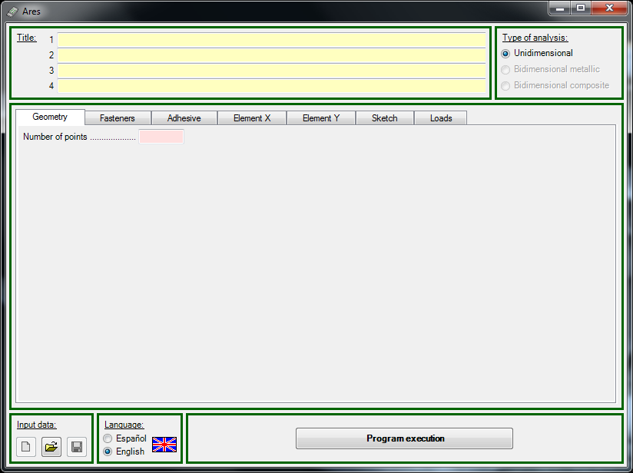
        - “Clean” input data form (“Geometry” tab)

The first tab (Geometry) and the first data to introduce in the graphical interface are the number of points required to model the unidimensional joint, and the locations of these points along the X axis.
The second tab (Fasteners) requests for the fasteners of the joint: number of groups of fasteners, locations of the groups and individual fasteners, their diameter, elastic modulus, shear stiffness (optional), and shear strength.
The third tab (Adhesive) requests for the adhesive properties: thickness of the adhesive ply and the stress/strain curve in shear (details in following chapter).
Fourth (Element X) and fifth (Element Y) tabs request for the data of the 2 adherents of the joint. They can be metallic or composite laminates. At each point/section, user shall have to introduce thickness, elastic moduli, coefficient of thermal expansion and allowable strengths (details in following chapter).
The following tab (Sketch) shows a graphical result of the data previously introduced, and finally, the last tab (Loads) requests for the axial and shear loads applied at adherents ends.
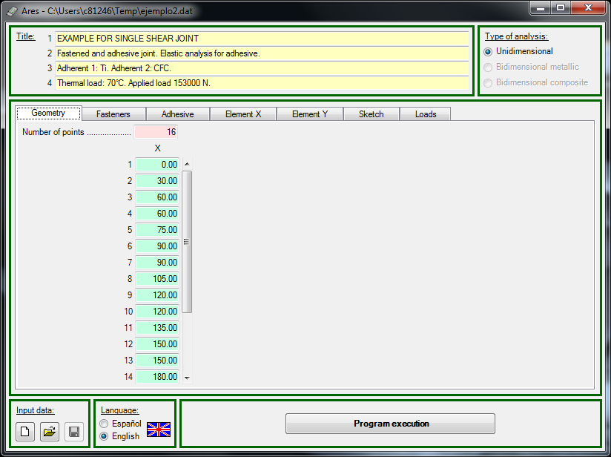
        - Geometry tab : number of points and their X-coordinates

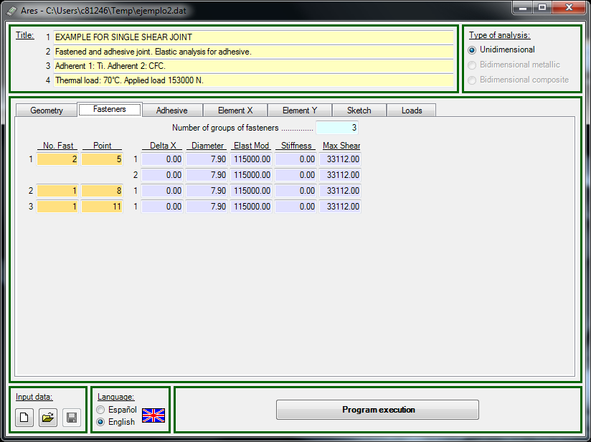
        - Fasteners tab : number, locations and properties

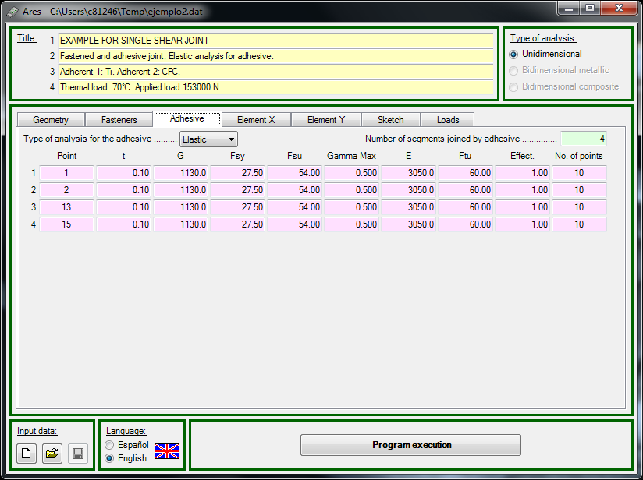
        - Adhesive tab : locations and properties

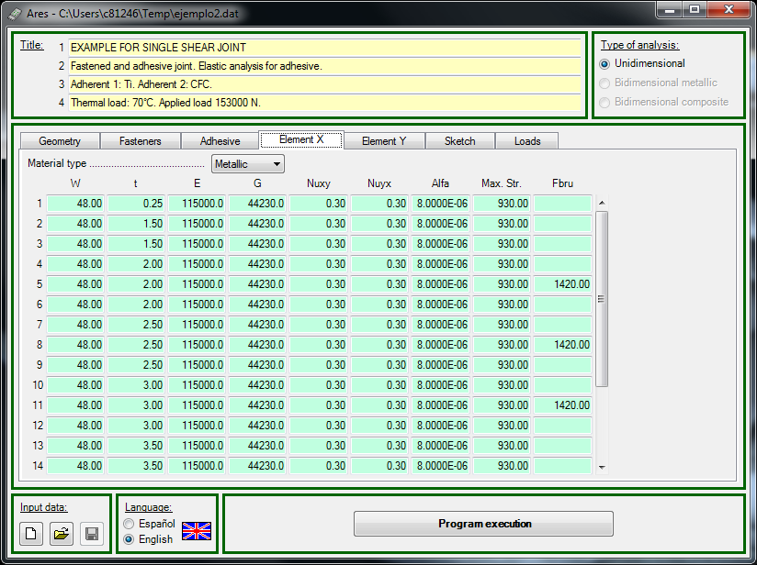
        - Adherent X tab : section and material properties per location (metallic example)
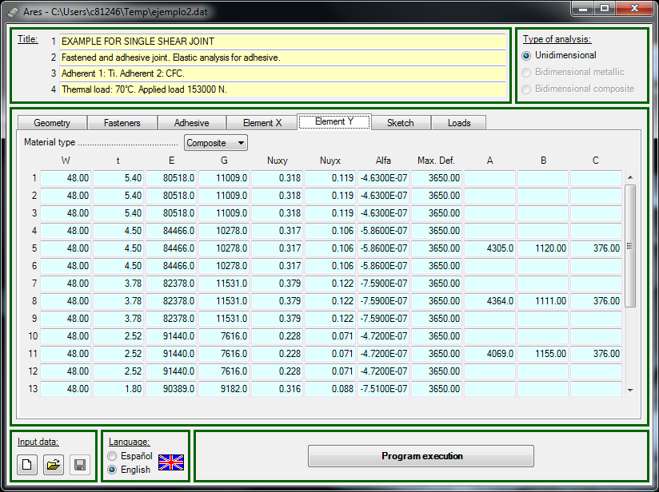
        - Adherent Y tab: section and material properties per location (composite example)

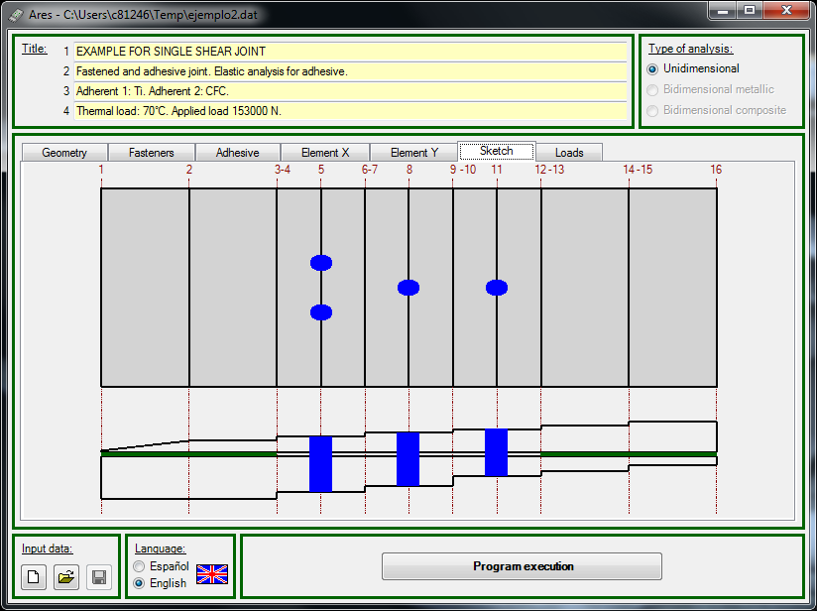
        - Sketch tab: graphical interpretation of input data

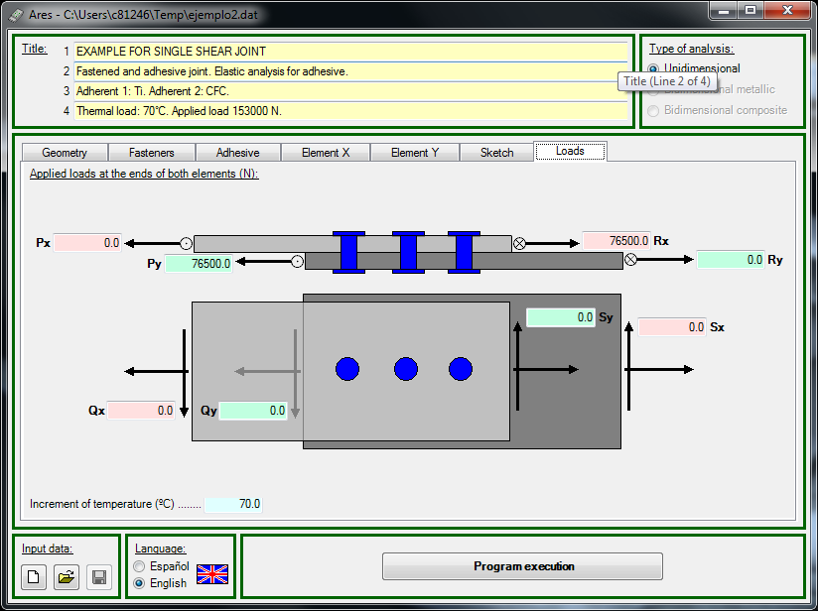

        - Loads tab: applied loads Sy & Sx MUST BE PERMUTED IN FIGURE

INPUT FILE
The data required for program execution can be introduced by means of a text file prepared by the user. The program asks for the complete name of this file and for a filename (without the extension) of the results file. If the data file does not exist, execution ends after emitting the corresponding error message.
The data included in the data file is divided into blocks. Some of these blocks, such as the header blocks, are common to all types of analysis. Subsequent data blocks may vary, depending on the type of joint to be analyzed.
The data items in each line must be separated by spaces.
The basic structure of all data blocks is the same. The first line of each block starts with the block number, which must always start in the first column. The rest of this line may contain a comment. These comments are not used by the program, nor do they appear in the results file. The following lines contain the data corresponding to the block.
In case of an error in the input data, the subroutine that reads the input file has been designed to provide a message of error indicating the kind of problem as well as the block where it is present to allow later modifications.
The different blocks are described in more detail in following pages, after the remark about the units system.

Units
The program has been designed to use the following units:
Length: millimetre (mm)
Force: Newton (N)
Stress: Mega Pascal (MPa)
Modulus: Mega Pascal (MPa)
If other units are used, problems may appear in the output format of the results file and the presentation of the input data, even if the program has performed the calculations correctly.

Header
Blocks 1 and 2 constitute the header section and contain the following items. Remember that the block number is obligatory and that the rest of this line may contain a comment.
- Title of the problem
This block contains four (4) lines for a title and comments concerning the problem to be analyzed. The program always reads these 4 lines, so they must be included, even though they may be blank lines.
- Dimensionality of the analysis
This line remains for backward compatibility even the bi-dimensional analysis has been disabled in ARES 4. The type of problem must be indicated here, UNIDIMENSIONAL. The use of capital or lower-case letters is not relevant.

Unidimensional case
Problems are considered to be unidimensional when a single line of fasteners is to be analyzed, with or without adhesive, or the analysis concerns a part of a joint in which there are no transverse variations in the plane of the materials joined.
The identification of the two elements to be joined may be interchanged, there being no requirement to identify element number 1 as being either the upper or the lower element, nor that which is subject to loads from either the right or the left as shown in the diagram of the joint.
The data blocks to be included in the data file are as follows:
- Geometry of the problem: Selected points
Points must be selected to divide the joint into sections for analysis. These points must denote the positions of changes in the joint such as the thickness, modulus or width of either of the elements being joined, changes in the thickness or effectiveness of the adhesive, changes in the type of adhesive, the positions of fasteners, etc. Since it will be also possible to select the number of subdivisions of the adhesive segments, between two successive data points, to be used in the calculations, it is not necessary to define additional points here to improve the precision of the calculations. When a change of any property (e.g., thickness) occurs at a geometric point, two points must be defined with the same geometric co-ordinate, but showing the difference in the property concerned. Figure below shows an example of such duplicated nodes.

1
2
3
4
5
1
2
5
8
9
3
4
6
7

        - Examples of definitions of point

The format of this data block is as follows (the comment in the first line is optional):

3 [Problem geometry]
NP
1 XP₁
… …
… …
NP XP_{NP}

…where: NP Number of points defined. This data is on a line of its own, with no additional data.
XP_{i} Co-ordinate of point i.They must be in ascending order, i.e. XP_{i-1} < XP_{i}

- Fastener data
When several fasteners are grouped around a single geometric point, the program considers them as one item and treats them as a single load-transfer point. This is known as a group of fasteners.
The format of this block is as follows (the comment in the first line is optional).

4 [Fastener data]
NG
1 NR₁ IP₁ Δ_{1,1} Φ_{1,1} ER_{1,1} K_{1,1} FS_{1,1}
…
Δ_{1,NR1} Φ_{1,NR1} ER_{1,NR1} K_{1,NR1} FS_{1,NR1}

2 NR₂ IP₂ Δ_{2,1} Φ_{2,1} ER_{2,1} K_{2,1} FS_{2,1}
…
Δ_{2,NR2} Φ_{2,NR2} ER_{2,NR2} K_{2,NR2} FS_{2,NR2}

…

NG NR_{NG} IP_{NG} Δ_{NG,1} Φ_{NG,1} ER_{NG,1} K_{NG,1} FS_{NG,1}
…
Δ_{NG,NRNG} Φ_{NG,NRNG} ER_{NG,NRNG} K_{NG,NRNG} FS_{NG,NRNG}

… where:
NG Total number of groups of fasteners. This data must be on a line of its own, with no additional data.
i Ordinal number identifying the group of fasteners, from 1 to NG
NR_{i} Number of fasteners in group i
IP_{i} Number of the point where group i is located. This must be one of the points defined in data block 3.
Δ_{i,j} Incremental co-ordinate of fastener j in group i, i.e., the co-ordinate of the fastener minus the co-ordinate of the data point at which the group is located (see following figure)
Φ_{i,j} The diameter of fastener j in group i
ER_{i,j} The elastic modulus of fastener j in group i
K_{i,j} The stiffness of fastener j in group i. If zero stiffness is specified, the program will calculate the stiffness as specified in the CASA Design Manual (Table 7.3-2 in chapter dedicated to Riveted Joint in Vol. 11 of Ref. 7).
FS_{i,j} Allowable single-shear load for fastener j in group i

IP_{i}
Δ_{i,j}
Δ_{i,j} = 0 for this group

        - Definition of Δ
Notes:
- When no fasteners are used in the joint being analyzed, data block 4 must still be included in the data file, indicating the total number of groups of fasteners as 0. No additional data is needed. The format of block 4 in these cases will be as follows (the comment in the first line is optional).

4 [Fastener data]
0

- Note that when a group is composed of several fasteners, the data for each fastener is introduced in a separate line. The data for the second and following fasteners within a group starts with the incremental co-ordinate, omitting the data corresponding to the number of fasteners and the position of the group. The data for the first fastener of each group is placed in the first line of the group, after the data showing the number of the group, the number of fasteners in the group and its position.

- Adhesive data
When an adhesive is used in the joint, the analysis may consider it to be elastic or non-elastic, as the user specifies. In both cases, the shear stress-strain curve for the adhesive must be defined, and data must be given for the axial forces acting on the adhesive.
Data for the adhesive must be supplied separately for each segment of the joint where adhesive is used. Adhesive segments extend from the starting point of the segment to the next point (points as defined in data block 3).
Different adhesive segments may be combined with segments without adhesive, and adhesive segments may also contain fasteners. For each adhesive segment, an effectiveness factor is included. This means that by changing the value of this factor, the segment may be treated as being totally bonded or as disbonded. The stretch of adhesive is subdivided into discrete points, which are used both for calculation purposes and for the presentation of the results. The maximum number of subdivisions in each adhesive segment is 20. The greater the number of subdivisions, the closer the calculated results will be to the true curve.
This data block has the following format (the comment in the first line is optional)
5 [Adhesive data]
IEL
NS
IP₁ TA₁ GA₁ FSYA₁ FSUA₁ γ₁ EA₁ FTUA₁ IEF₁ NPA₁
…
IP_{NS} TA_{NS} GA_{NS} FSYA_{NS} FSUA_{NS} γ_{NS} EA_{NS} FTUA_{NS} IEF_{NS} NPA_{NS}
…where:
IEL Type of analysis to be performed:
0: Linear elastic
1: Inelastic. The program takes into account the stress-strain curve that is specified later
NS The number of segments with adhesive bonding. This number must be on a line of its own, with no additional data. The maximum value is one less than the number of datum points defined in data block 3.
IP_{i} The starting point of the adhesive segment, as defined in data block 3. This means that there is adhesive between this point and the subsequent point.
TA_{i} The thickness of the adhesive in segment i.
GA_{i} The shear modulus (stiffness) of the adhesive in segment i, corresponding to the linear portion of the shear stress-strain curve (see following figure).
FSYA_{i} The adhesive's elastic limit stress. This should not be confused with the yield stress, which corresponds to a permanent plastic deformation of 0.2%. This limit corresponds to the end of the straight portion of the stress-strain curve.
FSUA_{i} The maximum shear stress that the adhesive in segment i will support (see figure 4.4).
γ_{i} The maximum shear strain, corresponding to the maximum shear stress of the adhesive in segment i (see following figure).
EA_{i} Young's modulus (tensile) of the adhesive in segment i.
FTUA_{i} Tension ultimate stress of the adhesive in segment i. When one of the materials being joined is a composite, the allowable tensile stress at right angles to the surface of the laminate must also be considered, since in some cases it may be lower than the ultimate stress of the adhesive. The value given here must be the lower of these two values. This value is only used in the calculation of peeling stresses.
IEF_{i} The effectiveness of the adhesive in segment i:
0: Disbonded
1: Fully adhered
NPA_{i} The number of connecting points wanted for the discretization of segment i that will be used in the calculations. Maximum value = 20
Notes:
- If no adhesive is used in the joint being analyzed, data block 5 must still be included, but only down to the number of adhesive segments (NS), which must be set to 0. In this case, the type of analysis (elastic or non-elastic) makes no difference. However, since at the moment there is no other type of non-linear analysis except for that corresponding to the adhesive, it is recommended that linear analysis be specified. The data block format in this case will be as follows (the comment in the first line is optional):

5 [Adhesive data]
0
0

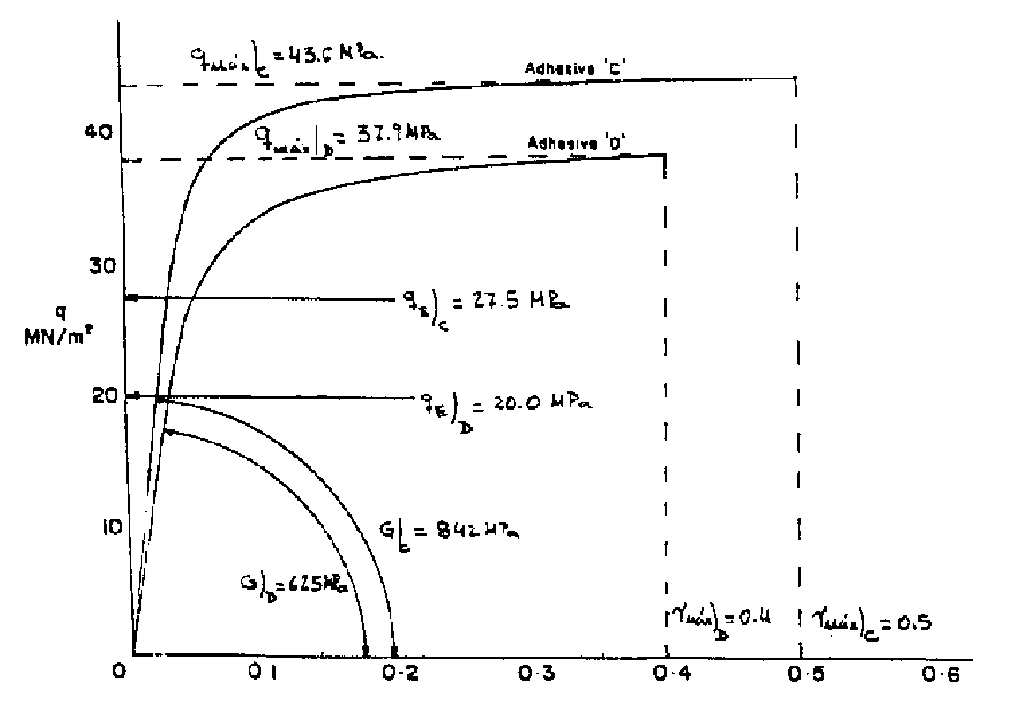
        - Example of adhesive shear stress-strain curve and its definition parameters

- Data for element X (or element 1)
The data in this block defines the section properties of the first adherent. It may be either of metallic or composite material. The allowable stresses corresponding to the fastened joint should also be specified here also if it the strength check of the bolted joint is needed. Data must be supplied, on a separate line, for each of the points defined in data block 3.
This data block has the following format (the comment in the first line is optional).

6 [Data for element 1]
TMA
1 AN₁ T₁ E₁ G₁ ν12₁ ν21₁ CT₁ FT₁ FB₁ [A₁ C₁ ]
…
NP AN_{NP} T_{NP} E_{NP} G_{NP} ν12_{NP} ν21_{NP} CT_{NP} FT_{NP} FB_{NP} [A_{NP} C_{NP}]

…where:
TMA Code indicating the type of material:
1: Metallic
2: Composite material
i Ordinal number identifying the points/sections, from 1 to NP
AN_{i} Width of the element at point i.
T_{i} Thickness of the element at point i.
E_{i} Longitudinal Young's modulus of the element at point i.
G_{i} Shear modulus (stiffness) of the element at point i.
ν12_{i} Poisson's ratio in direction 1 (*) for the element at point i.
ν21_{i} Poisson's ratio in direction 2 (*) for the element at point i., where typically:
ν₂₁ = (E₂ / E₁) · ν₁₂
* In this context 1 is the longitudinal direction and 2 the transversal direction
CT_{i} Coefficient of thermal expansion along the length of the element at point i.
FT_{i} Axial strength of the element at point i. This will be the ultimate stress or the maximum microstrain, depending on whether the element is metallic or composite, respectively.
FB_{i}(*) The allowable ultimate bearing stress of metallic elements or, for composite laminates, the tension through the hole allowable stress (point B in CASA method, see Ref. 5) at a rivet position.
A_{i}(*)(#) For composite materials, the tension by-pass allowable strain (point A in CASA method, in microstrains) of the laminate at a rivet position.
C_{i}(*)(#) For composite materials, the allowable bearing stress (point C in CASA method) due to the load transmitted by the fastener.
Notes:
- Items marked (#) are not required for metallic materials.
- For composite materials, the items marked (*) are optional. No strength analysis of the composite bolted joint will be done if not included.
- The data corresponding to allowable stresses or strains should only be included for points where there is a fastener.

- Data for element Y (or element 2)
The structure of the data for block 7, corresponding to Element Y, is the same as for block 6.

- Applied loads
All loads, both axial and shear, must be specified, even though their value is zero.
This data block has the following format (the comment in the first line is optional).

8 [Applied loads]
Px Rx Py Ry
Qx Sx Qy Sy
ITE

..where:
Px Axial load applied to the left-hand end of element X.
Rx Axial load applied to the right-hand end of element X.
Py Axial load applied to the left-hand end of element Y.
Ry Axial load applied to the right-hand end of element Y.
Qx Shear load applied to the left-hand end of element X.
Sx Shear load applied to the right-hand end of element X.
Qy Shear load applied to the left-hand end of element Y.
Sy Shear load applied to the right-hand end of element Y.
ITE Temperature increment. The difference between the working temperature and the reference temperature.
The positive directions as shown in figure below.

P_{x}
Q_{x}
Element 1
Element 2
S_{x}
R_{x}
P_{y}
Q_{y}
S_{y}
R_{y}
X

        - Applied loads
In many cases, when loads are applied to one of the elements being joined (element X), and reacted at the other element (element Y), only Px and Ry (for axial loads) and/or Qx and Sy (for shear loads) will have non-zero values.

OUTPUT RESULTS

WINDOWS PC/GUI
In the Windows/PC GUI version, when all data is entered and the button ‘Program execution’ is pressed, the program runs and a form with the results calculated by the program are shown. As option, those output results can be saved in a text file. The content of this file is described in following sub-chapter.

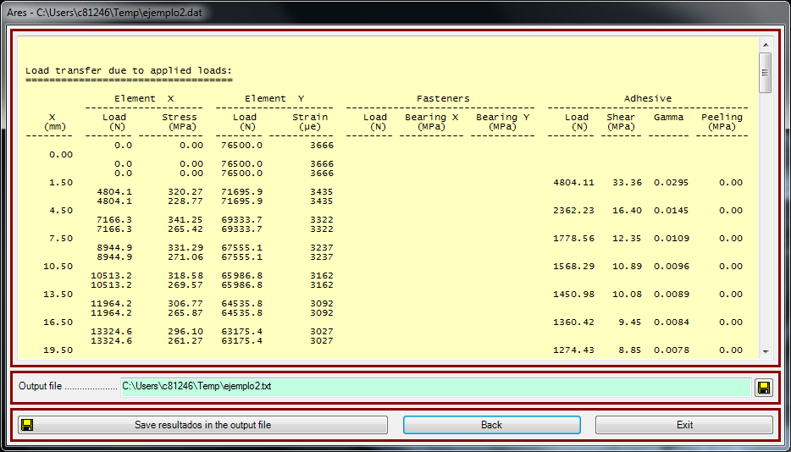
        - Results form for an ARES analysis
NOTE (UPDATE FOR ISSUE B)
Output columns for internal loads per section in elements:
- Load: resultant load, accounting for axial and shear loads, i.e., P = ( N² + S² )^{0.5}
- Axial-Str (metallic) / Def-0º (composite) : axial stress in metallic elements, or axial strain (at 0º plies) in composites
- Shear-Str (metallic) / Def-45º (composite) : shear stress in metallic elements, or critical (maximum in absolute value) strain at ±45º plies in composites
(… see also annex in last page)

OUTPUT FILE
This file will contain the following blocks of data.
- An echo of the input data (see below)
- For the applied loads, at those sections defined along the joint:
  - The stress/strain state and the internal load in the elements/adherents.
  - The shear load transferred by each fastener, as well as the corresponding bearing stresses in adherents.
  - The shear load transferred by the adhesive, plus the corresponding stress and strain.
Note that, even for analyses with non-linear adhesive and high applied loads, the program will present an “internal loads distribution” for the applied loads, because during this phase of the analysis it considers all the elements of the joint are effective. In other words, during this phase, the program is neither calculating Reserve Factors, nor removing the stiffness of the failed parts. Then, for cases with RF<1, this result, the internal loads distribution for the applied loads, will be unrealistic.
- The Reserve Factor for the adherents, the fasteners and the adhesive.
- If the analysis is not linear, the internal loads, the stresses and the strains at the adherents, fasteners and adhesive joints for the failure loads are also presented.
When the RF is lower than 1, and analysis is linear, the internal loads distribution is NOT presented for failure loads. Then, to obtain the internal loads at failure the user should multiply the internal loads at applied load level by the Reserve Factor.
The failure modes considered are:
- Strength of the elements/adherents using their allowable stresses/strains
- Bearing/by-pass failure at the fastener locations, and fasteners failure
- Strength of the adhesive
The program starts by calculating the first of the failure modes noted above. If the first failure occurs in any of the elements/adherents, when its stress/strain reaches the material allowable, the program continues execution considering higher loads.
When, on increasing loads, the program finally reaches failure in the any of the joining parts (fastener, bearing/by-pass, or adhesive), the execution is stopped and actual internal loads are presented as the failure loads. The program does not continue calculating internal loads at higher load levels, even though the adherents had not reached their allowable stresses/strains.

The results file is also divided into data blocks, in a similar way to the data input file. The contents of these blocks will vary slightly, according to the type of analysis performed.
When the analysis is for linear problems the basic structure is:
- The title of the analysis. This is exactly the same as block 1 of the data file
- A sketch of the geometry of the problem
- The applied loads
- Materials and geometry. This includes the data for the elements to be joined (thickness, modulus, coefficient of thermal expansion, etc.). An explanation of the meaning of each item is included at the start of some blocks.
- Allowable strengths of the adherents, in terms of stress for metal parts, or strain for composite laminates
- Bearing/by-pass strengths of the riveted joints, i.e. the bearing allowable stresses (F_{bru} for metals or C for composites) and, for composites, the tension-by-pass allowable strains (A), and the tension-through–the-hole allowable stresses (B)
- Fasteners data, including their positions, diameters, moduli and stiffnesses
- For each group of fasteners, its effective centre and the stiffness of the group
- Data of the adhesive segments
- Internal loads distribution for applied loads, Reserve Factors and internal loads distribution for failure loads are presented afterwards according to explanations in previous page.
In the case of joints involving both axial and shear loads, the load distribution along the length of the joint corresponds to the combination of both external loads, giving the total load applied at each point. The stress in metallic materials is the Von Mises stress, while the microstrains in composite elements corresponds to the maximum value of the strains in the fibres at 0º and 45º.

WARNING AND ERROR MESSAGES
The program is designed to give different error messages, which are commonly generated while reading the input data, according to the data block where the error was detected. There are two general error messages referring to the input data file and the data blocks in it:
- Non existent data file.
- Bad input data in input file.
The errors corresponding to each block are:
- Title
End of file while reading group 1 in input file (Title)
- Type of analysis
End of file while reading group 2 in input file (Type)
Group 2 is defined badly (Type)
In the case of unidimensional analyses:
- Geometric points
End of file while reading group 3 in input file (Points)
Group 3 is defined badly (Points)
- Fasteners
End of file while reading group 4 in input file (Fasteners)
Group 4 is defined badly (Fasteners)
- Adhesive
End of file while reading group 5 in input file (Adhesive)
Group 5 is defined badly (Adhesive)
- Element X
End of file while reading group 6 in input file (Material X)
Group 6 is defined badly (Material X)
No coincidence of data and material type (Material X)
- Element Y
End of file while reading group 7 in input file (Material Y)
Group 7 is defined badly (Material Y)
No coincidence of data and material type (Material Y)
- Applied loads
End of file while reading group 8 in input file (Loads)
Group 8 is defined badly (Loads)

After this, the program carries out a series of checks that may generate the following error messages:
- Non-existence of a data block.
Group 1 missing in input file (Title)
Group 2 missing in input file (Type)
Group 3 missing in input file (Points)
Group 4 missing in input file (Fasteners)
Group 5 missing in input file (Adhesive)
Group 6 missing in input file (Material X)
Group 7 missing in input file (Material Y)
Group 8 missing in input file (Loads)
- Unbalance of the applied loads.
Axial applied loads are not in equilibrium
Shear applied loads are not in equilibrium
- Program limits exceeded.
Too many elements exceeding the program capability
Too many fasteners in an element exceeding the program capability
Too many adhesive divisions between two points exceeding the program capability
- Fasteners and adhesive defined before defining the geometry.
Group 4 (Fasteners) cannot be defined before group 3 (Points)
Some group of fasteners is located in a nonexisting point
Group 5 (Bonding) cannot be defined before group 3 (Points)
Some adhesive is applied in a nonexisting zone
- No fixings of any type defined
Neither fastening nor bonding have been specified in input data
- Problems in the resolution of the system of linear equations.
The flexibility matrix is singular. Unrecoverable kind of error

LIMITATIONS
As noted in the introduction chapter of this report, the scope and applicability of this program are:
- Calculation of internal loads in fastened and/or adhesive joints
- Unidimensional joints
- Elements being joined metallic or composite
- Program assumes that the elements to be joined (adherents) have linear elastic behaviour
- Fasteners are assumed to have linear elastic behaviour, with no variations in their stiffness, even when joining metallic elements
- Calculations involving adhesives take into account their non-linear behaviour when subjected to shear stress (no interaction with axial stresses is accounted)
- The strength of the different elements of the joint is checked: adherents, fasteners and adhesive

The main limitations of this program are related with the maximum number of points, fasteners and adhesive subdivisions, is able to handle. These limits are:
- Maximum number of points/sections along the joint: 50
- Maximum number of fasteners per point/section: 5
- Maximum subdivisions of an adhesive segment: 20

EXAMPLES
Some examples of cases of use of ARES are available in the Windows server repository:
\\Cae\Infocalculo\Soft\Ares\ejemplos
Input and output data files of one of those examples are shown herein
The example used is that defined in the specifications of the program (Ref. 4). This is used as the basic problem since it combines metallic and composite materials, with fasteners and adhesive

EXAMPLE 1: UNIDIMENSIONAL ANALYSIS 1
Figure below shows the definition of the unidimensional problem. This corresponds to a Ti-CFC adhesive joint in which there are three segments without adhesive bonding. The intention is to analyse the effect of including three fasteners in the debonded segments.
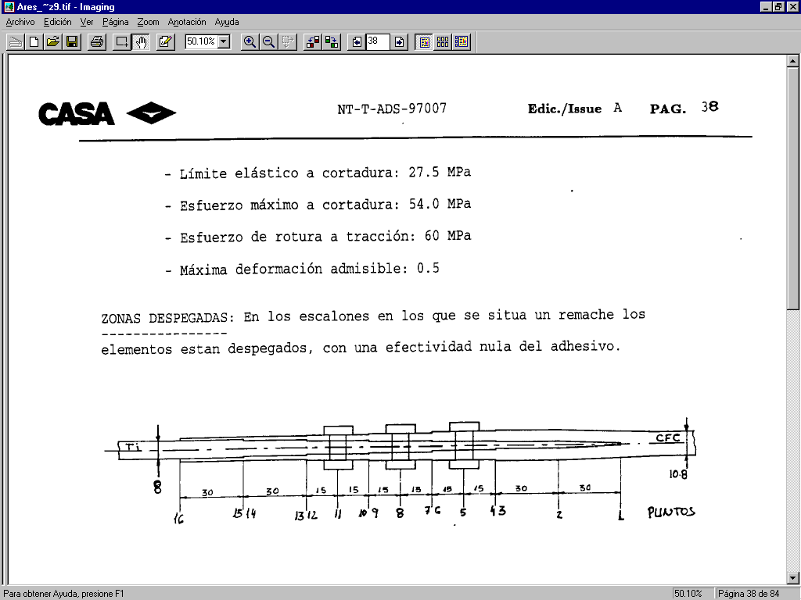
        - The unidimensional problem

The data items for this problem are:
ELEMENT 1: Ti-6Al-4V Annealed
Thickness (mm) from left to right: 8, 7, 6, 5, 4, 3, 0.5
Modulus: 110316 MPa
F_{tu}: 930 MPa
F_{bru}: 1420 MPa
Coefficient of thermal expansion: 8.0E-6 mm/mm/ºC

ELEMENT 2: Composite material made of Z-19.775 carbon fibre.
Layers, as numbers of plies oriented at 0º, +/- 45º and 90º. From left to right (the problem is symmetrical):
- (8/4/0)
- (14/4/2)
- (20/4/4)
- (26/12/4)
- (32/12/6)
- (36/16/8)
Properties of the laminate material:
- Longitudinal Young's modulus: 120000 MPa.
- Transversal modulus: 9000 MPa.
- Shear modulus: 3700 MPa.
- Poisson's ratio: 0.3
- Coefficient of longitudinal thermal expansion: -1.3E-6 mm/mm/ºC
- Coefficient of transversal thermal expansion: 31.3E-6 mm/mm/ºC
- Maximum deformation of the laminate: 3650 με
- Allowable limits for the fasteners: As per NT-00-ECE-037

FASTENERS: DAN5-10. Allowable double shear load 66224 N

ADHESIVE:
Nominal thickness: 0.1 mm
Shear modulus: 1130 MPa.
Axial modulus: 3050 MPa.
Elastic shear limit: 27.5 MPa.
Maximum shear stress: 54.0 MPa.
Tensile breaking stress: 60 MPa.
Maximum allowable deformation: 0.5

NON-BONDED SEGMENTS: The segments where there are fasteners are disbonded, with zero effectiveness of the adhesive.

The joint is tapered, with changes in thickness in both elements being joined, so there will be double datum points at certain geometric points involved in this problem. Datum points must also be defined for the fasteners.
Since this is a double shear connection, only half of the problem will be analysed. The thickness given for the Ti will be half of the thickness shown above in the definition. The data shown for the fibre composite also correspond to the total thickness, so these values will also be halved. The modulus, the Poisson ratios and the thermal expansion coefficients should be determined previously, using a program suitable for calculating these values for composite materials.
Finally, it must be noted that the data introduced into the input data file starts at the right-hand side of the joint.
The first example is a linear analysis of this problem.

- Content of file ejemplo1.dat

1 Title and remarks (4 lines)
EXAMPLE FOR SINGLE SHEAR JOINT
Fastened and adhesive joint. Plastic analysis for adhesive.
Adherent 1: Ti. Adherent 2: CFC.
Thermal load: 70°C. Applied load 153000 N.
2 Type of problem
Unidimensional
3 Geometry: N / i - X(i)
16
1 0.00
2 30.00
3 60.00
4 60.00
5 75.00
6 90.00
7 90.00
8 105.00
9 120.00
10 120.00
11 135.00
12 150.00
13 150.00
14 180.00
15 180.00
16 210.00
4 Fasteners data: NG / i Nr(i) Ind(i) Dx(i,k) D(i,j) Er(i,j) Kr(i,j) Fsu(i,j)
3
1 2 5 0.00 7.90 115000.0 0.00 33112.00
0.00 7.90 115000.0 0.00 33112.00
2 1 8 0.00 7.90 115000.0 0.00 33112.00
3 1 11 0.00 7.90 115000.0 0.00 33112.00
5 Adhesive data: An / Na / Ind(i) t(i) G(i) Fsy(i) Fsu(i) Gamma(i) E(i) Ftu(i) Eff(i) Np(i)
1
4
1 0.10 1130.0 27.50 54.00 0.500 3050.0 60.00 1.000 10
2 0.10 1130.0 27.50 54.00 0.500 3050.0 60.00 1.000 10
13 0.10 1130.0 27.50 54.00 0.500 3050.0 60.00 1.000 10
15 0.10 1130.0 27.50 54.00 0.500 3050.0 60.00 1.000 10
6 Data for Element X: Mat / i W(i) t(i) e(i) G(i) µ1(i) µ2(i) Ct(i) Ftu(i) [Fbru(i)]
1
1 48.00 0.25 115000.0 44230.0 0.30 0.30 8.0000E-06 930.00
2 48.00 1.50 115000.0 44230.0 0.30 0.30 8.0000E-06 930.00
3 48.00 1.50 115000.0 44230.0 0.30 0.30 8.0000E-06 930.00
4 48.00 2.00 115000.0 44230.0 0.30 0.30 8.0000E-06 930.00
5 48.00 2.00 115000.0 44230.0 0.30 0.30 8.0000E-06 930.00 1420.00
6 48.00 2.00 115000.0 44230.0 0.30 0.30 8.0000E-06 930.00
7 48.00 2.50 115000.0 44230.0 0.30 0.30 8.0000E-06 930.00
8 48.00 2.50 115000.0 44230.0 0.30 0.30 8.0000E-06 930.00 1420.00
9 48.00 2.50 115000.0 44230.0 0.30 0.30 8.0000E-06 930.00
10 48.00 3.00 115000.0 44230.0 0.30 0.30 8.0000E-06 930.00
11 48.00 3.00 115000.0 44230.0 0.30 0.30 8.0000E-06 930.00 1420.00
12 48.00 3.00 115000.0 44230.0 0.30 0.30 8.0000E-06 930.00
13 48.00 3.50 115000.0 44230.0 0.30 0.30 8.0000E-06 930.00
14 48.00 3.50 115000.0 44230.0 0.30 0.30 8.0000E-06 930.00
15 48.00 4.00 115000.0 44230.0 0.30 0.30 8.0000E-06 930.00
16 48.00 4.00 115000.0 44230.0 0.30 0.30 8.0000E-06 930.00

...

        - Extract of ejemplo1.dat : input data (i)

Rest of input data file in following page…

...

7 Data for Element Y: Mat / i W(i) t(i) e(i) G(i) µ1(i) µ2(i) Ct(i) Ftu(i) [B(i) A(i) C(i)]
2
1 48.00 5.40 80518.0 11009.0 0.318 0.119 -4.6300E-07 3650.00
2 48.00 5.40 80518.0 11009.0 0.318 0.119 -4.6300E-07 3650.00
3 48.00 5.40 80518.0 11009.0 0.318 0.119 -4.6300E-07 3650.00
4 48.00 4.50 84466.0 10278.0 0.317 0.106 -5.8600E-07 3650.00
5 48.00 4.50 84466.0 10278.0 0.317 0.106 -5.8600E-07 3650.00 1120.00 4305.0 376.00
6 48.00 4.50 84466.0 10278.0 0.317 0.106 -5.8600E-07 3650.00
7 48.00 3.78 82378.0 11531.0 0.379 0.122 -7.5900E-07 3650.00
8 48.00 3.78 82378.0 11531.0 0.379 0.122 -7.5900E-07 3650.00 1111.00 4364.0 376.00
9 48.00 3.78 82378.0 11531.0 0.379 0.122 -7.5900E-07 3650.00
10 48.00 2.52 91440.0 7616.0 0.228 0.071 -4.7200E-07 3650.00
11 48.00 2.52 91440.0 7616.0 0.228 0.071 -4.7200E-07 3650.00 1155.00 4069.0 376.00
12 48.00 2.52 91440.0 7616.0 0.228 0.071 -4.7200E-07 3650.00
13 48.00 1.80 90389.0 9182.0 0.316 0.088 -7.5100E-07 3650.00
14 48.00 1.80 90389.0 9182.0 0.316 0.088 -7.5100E-07 3650.00
15 48.00 1.08 85477.0 12836.0 0.639 0.127 -1.8100E-06 3650.00
16 48.00 1.08 85477.0 12836.0 0.639 0.127 -1.8100E-06 3650.00
8 Applied loads: Px Rx Py Ry / Qx Sx Qy Sy / T
0.0 76500.0 76500.0 0.0
0.0 0.0 0.0 0.0
70.0

        - Extract of ejemplo1.dat : input data (ii)

- Content of file ejemplo1.txt

EXAMPLE FOR SINGLE SHEAR JOINT
Fastened and adhesive joint. Plastic analysis for adhesive.
Adherent 1: Ti. Adherent 2: CFC.
Thermal load: 70°C. Applied load 153000 N.

Geometry:
=========

Point number 1 2 3 4 · · · Np-3 Np-2 Np-1 Np
Gr. of Fast. number: 1 2 · · · N-1 N

Element X: Px <---- #=====#=====#=====#= · · · =#=====#=====#=====# ----> Rx
| | | |
Element Y: Py <---- #=====#=====#=====#= · · ·=#=====#=====#=====# ----> Ry

|-----> X

Applied loads (N):
==================

Axial
-----
Px = 0.0 Rx = 76500.0 Delta Temp = 70.00 ºC
Py = 76500.0 Ry = 0.0

Shear
-----
Qx = 0.0 Sx = 0.0
Qy = 0.0 Sy = 0.0

        - Extract of ejemplo1.txt : eco of input data (i)

Rest of output results file in following pages…

1
Materials properties and geometry:
==================================
W <- Width
t <- Thickness
E <- Elastic modulus
G <- Shear modulus
Nuxy <- Poisson ratio <xy>
Nuyx <- Poisson ratio <yx>
Alfa <- Thermal expansion coeficient

Element X (Metallic) Element Y (Composite)
-------------------------------------------------- --------------------------------------------------
X W t E G Nuxy Nuyx Alfa W t E G Nuxy Nuyx Alfa
Pt (mm) (mm) (mm) (MPa) (MPa) (mm/mm/C) (mm) (mm) (MPa) (MPa) (mm/mm/C)
--- ------- ----- ----- ------- ------- ----- ----- ---------- ----- ----- ------- ------- ----- ----- ----------
1 0.00 48.00 0.25 115000 44230 0.300 0.300 8.000E-06 48.00 5.40 80518 11009 0.318 0.119 -4.630E-07
2 30.00 48.00 1.50 115000 44230 0.300 0.300 8.000E-06 48.00 5.40 80518 11009 0.318 0.119 -4.630E-07
3 60.00 48.00 1.50 115000 44230 0.300 0.300 8.000E-06 48.00 5.40 80518 11009 0.318 0.119 -4.630E-07
4 60.00 48.00 2.00 115000 44230 0.300 0.300 8.000E-06 48.00 4.50 84466 10278 0.317 0.106 -5.860E-07
5 75.00 48.00 2.00 115000 44230 0.300 0.300 8.000E-06 48.00 4.50 84466 10278 0.317 0.106 -5.860E-07
6 90.00 48.00 2.00 115000 44230 0.300 0.300 8.000E-06 48.00 4.50 84466 10278 0.317 0.106 -5.860E-07
7 90.00 48.00 2.50 115000 44230 0.300 0.300 8.000E-06 48.00 3.78 82378 11531 0.379 0.122 -7.590E-07
8 105.00 48.00 2.50 115000 44230 0.300 0.300 8.000E-06 48.00 3.78 82378 11531 0.379 0.122 -7.590E-07
9 120.00 48.00 2.50 115000 44230 0.300 0.300 8.000E-06 48.00 3.78 82378 11531 0.379 0.122 -7.590E-07
10 120.00 48.00 3.00 115000 44230 0.300 0.300 8.000E-06 48.00 2.52 91440 7616 0.228 0.071 -4.720E-07
11 135.00 48.00 3.00 115000 44230 0.300 0.300 8.000E-06 48.00 2.52 91440 7616 0.228 0.071 -4.720E-07
12 150.00 48.00 3.00 115000 44230 0.300 0.300 8.000E-06 48.00 2.52 91440 7616 0.228 0.071 -4.720E-07
13 150.00 48.00 3.50 115000 44230 0.300 0.300 8.000E-06 48.00 1.80 90389 9182 0.316 0.088 -7.510E-07
14 180.00 48.00 3.50 115000 44230 0.300 0.300 8.000E-06 48.00 1.80 90389 9182 0.316 0.088 -7.510E-07
15 180.00 48.00 4.00 115000 44230 0.300 0.300 8.000E-06 48.00 1.08 85477 12836 0.639 0.127 -1.810E-06
16 210.00 48.00 4.00 115000 44230 0.300 0.300 8.000E-06 48.00 1.08 85477 12836 0.639 0.127 -1.810E-06

        - Extract of ejemplo1.txt : eco of input data (ii)

Allowable tensile stress/strain:
================================

Elem. X Elem. Y
------- -------
X Max Str Max Def
Pt (mm) (MPa) (µe)
--- ------- ------- -------
1 0.00 930.00 3650
2 30.00 930.00 3650
3 60.00 930.00 3650
4 60.00 930.00 3650
5 75.00 930.00 3650
6 90.00 930.00 3650
7 90.00 930.00 3650
8 105.00 930.00 3650
9 120.00 930.00 3650
10 120.00 930.00 3650
11 135.00 930.00 3650
12 150.00 930.00 3650
13 150.00 930.00 3650
14 180.00 930.00 3650
15 180.00 930.00 3650
16 210.00 930.00 3650

Allowables for fastened joint:
==============================

Element X (Metallic) Element Y (Composite)
------------------------ ------------------------
Fbru A B C
Gr Nr (MPa) (µe) (MPa) (MPa)
--- --- ------ ------- ------- ------ ------- -------
1 1 1420.00 4305 1120.00 376.00
2 1420.00 4305 1120.00 376.00
2 1 1420.00 4364 1111.00 376.00
3 1 1420.00 4069 1155.00 376.00

Fasteners locations: 3
=======================

Delta X Diam Er Stiffness Allowable
Gr Pt Nr (mm) (mm) (MPa) (N/mm) (N)
--- --- --- ------- ------ -------- --------- ---------
1 5 1 0.00 7.90 115000 41581.08 33112.00
2 0.00 7.90 115000 41581.08 33112.00
2 8 1 0.00 7.90 115000 43409.49 33112.00
3 11 1 0.00 7.90 115000 40433.58 33112.00

Groups of fasteners. Global data:
=================================

C.G. Stiffness
Gr Pt (mm) (N/mm)
--- --- --------- ---------
1 5 75.00 83162.16
2 8 105.00 43409.49
3 11 135.00 40433.58

Adhesive segments: 4
=====================

Type of analysis: Plastic

t G Fty Ftu Gamma E Ftu No. of
Seg Pt - Pt (mm) (MPa) (MPa) (MPa) Max. (MPa) (MPa) points Eff.
--- ------- ----- ------ ----- ----- ------- ------ ------ ------ ----
1 1 - 2 0.10 1130.0 27.50 54.00 0.500 3050.0 60.00 10 1.00
2 2 - 3 0.10 1130.0 27.50 54.00 0.500 3050.0 60.00 10 1.00
3 13 - 14 0.10 1130.0 27.50 54.00 0.500 3050.0 60.00 10 1.00
4 15 - 16 0.10 1130.0 27.50 54.00 0.500 3050.0 60.00 10 1.00

        - Extract of ejemplo1.txt : eco of input data (iii)

Load transfer due to aplied loads:
===================================

Element X Element Y Fasteners Adhesive
-------------------- -------------------- -------------------------------- ----------------------------------
X Load Stress Load Strain Load Bearing X Bearing Y Load Shear Gamma Peeling
(mm) (N) (MPa) (N) (µe) (N) (MPa) (MPa) (N) (MPa) (MPa)
-------- -------- ----------- -------- ----------- -------- ----------- ----------- -------- ------- ------- ---------
0.0 0.00 76500.0 3666
0.00
0.0 0.00 76500.0 3666
0.0 0.00 76500.0 3666
1.50 4755.56 33.02 0.0314 0.00
4755.6 317.04 71744.4 3438
4755.6 226.46 71744.4 3438
4.50 2397.67 16.65 0.0147 0.00

...

120.00
34397.9 286.65 42102.1 2817
34397.9 238.87 42102.1 3806
120.00
34397.9 238.87 42102.1 3806
34397.9 238.87 42102.1 3806

135.00 1097.0 46.29 55.10
35494.9 246.49 41005.1 3707
35494.9 246.49 41005.1 3707
150.00
35494.9 246.49 41005.1 3707
35494.9 211.28 41005.1 5251
150.00
35494.9 211.28 41005.1 5251
35494.9 211.28 41005.1 5251
151.50 6676.04 46.36 0.0876 0.00
42170.9 251.02 34329.1 4396
42170.9 251.02 34329.1 4396
154.50 5105.96 35.46 0.0360 0.00
47276.9 281.41 29223.1 3742
47276.9 281.41 29223.1 3742

...

        - Extract of ejemplo1.txt : stresses and strains calculated for applied loads

Reserve factors for failure loads:
==================================

Element X
----------
Material: Metallic
The joint fails before the element

Element Y
----------
Material: Composite
Most loaded point: 151.50 mm
Allowable strain: 3650 µe
Reserve factor: 0.65

Joint:
------
Failure point: 135.00
Reserve factor: 1.04

Load transfer due to failure loads:
===================================

Element X Element Y Fasteners Adhesive
-------------------- -------------------- -------------------------------- ----------------------------------
X Load Stress Load Strain Load Bearing X Bearing Y Load Shear Gamma Peeling
(mm) (N) (MPa) (N) (µe) (N) (MPa) (MPa) (N) (MPa) (MPa)
-------- -------- ----------- -------- ----------- -------- ----------- ----------- -------- ------- ------- ---------
0.0 0.00 80085.9 3837
0.00
0.0 0.00 80085.9 3837
0.0 0.00 80085.9 3837

...

135.00 1155.9 48.77 58.06
37370.5 259.52 42715.5 3862
37370.5 259.52 42715.5 3862
150.00
37370.5 259.52 42715.5 3862
37370.5 222.44 42715.5 5470
150.00
37370.5 222.44 42715.5 5470
37370.5 222.44 42715.5 5470
151.50 6756.76 46.92 0.0887 0.00
44127.2 262.66 35958.7 4604
44127.2 262.66 35958.7 4604
...

        - Extract of ejemplo1.txt : Reserve Factors, stresses and strains for failure loads

ANNEX : REPORTED STRESSES
FOR REVISION B OF USER’S MANUAL

ARES 5
For metal parts, ARES reports axial stress (σ_{x}) and shear stress (τ_{xy}) for each element and section.
The static margin is obtained as Reserve Factor comparing the material ultimate stress (F_{tu}) with the Von Mises stress (σ_{vm}), where this is defined, for the quasi-unidimensional ARES problem (σ_{y}=0), as:
σ_{vm} = ( σ_{x}² + 3·τ_{xy}² )^{0.5}
If analysis requires the principal stresses, the following expressions can be used to do the transformation:
σ₁ = σ_{x}/2 + [ (σ_{x}/2)² + τ_{xy}² ]^{0.5}

σ₂ = σ_{x}/2 – [ (σ_{x}/2)² + τ_{xy}² ]^{0.5}

ARES 4
In the previous version, ARES reported the Von Mises stress (one data column instead of 2 for stresses), but also the resultant section load (P), combining axial load (N) and shear load (S). Then, taking into account section width (w) and thickness (t), as…

σ_{vm}² = σ_{x}² + 3·τ_{xy}²

P² = N² + S² -> [ P/(w·t) ]² = [N/(w·t)]² + [S(w·t)]² = σ_{x}² + τ_{xy}²
A simple linear system of two equations can be solved to get the axial and shear stresses:
σ_{vm}² = σ_{x}² + 3·τ_{xy}²

[ P/(w·t) ]² = σ_{x}² + τ_{xy}²

…

σ_{x}² = { 3·[ P/(w·t) ]² - σ_{vm}² } / 2

τ_{xy}² = { σ_{vm}² - [ P/(w·t) ]² } / 2

The transformation to principal stresses can be done as shown in previous section.

